22. Classification of Folds with Layer Thickness Variations
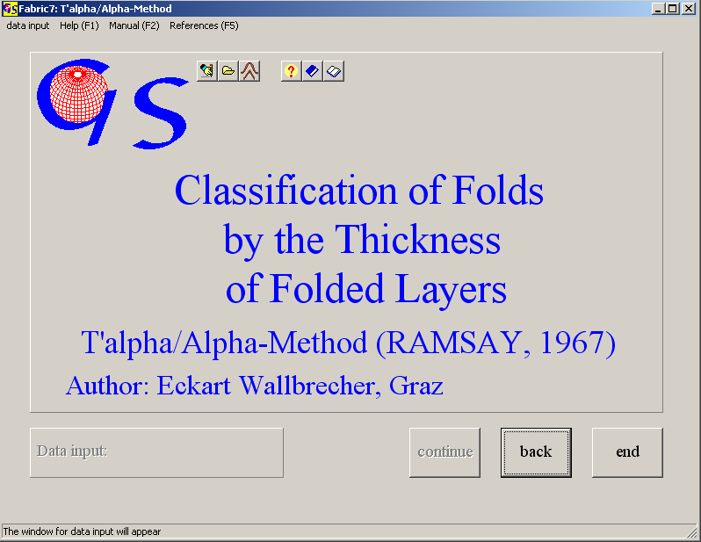
Fig 1

This program (Fig. 1) plots the distance between the two tangents on a folded layer, normalized by the hinge distance, against the dip angle of the tangents. Parallel folds produce a horizontal line, similar folds are plotted on a cosine function (RAMSAY, 1967).
Manual input is shown in Fig. 2. For each fold we need the hinge distance of two planes and the isogonal distances for all reachable isogons in steps of ten degrees. Files of saved data have the extension „.TAL“. In the data file the ratio T/T0 is saved. Fig. 6 shows the graphic form. The graphs for ideal parallel and similar folds are already plotted for comparison. Input from a data file is the same as in all other programs.
A very convenient method to acquire data is from a bitmap of the fold struc-tures. Images in *.bmp, *.gif, *.tif, *.jpg, *.wmf, or *.emf format can be used, or the image may be imported from the clipboard. (Fig. 3). The fold is rotated to an upright position by clicking with the left mouse button on two hinge points of a folded layer (Fig. 4). The hinge distance is calculated from the two points. Now either click on the button "Clockwise isogons" or "Anticlockwise isogons". The isogons are plotted in 10-degree steps.
Just move the tangents to the upper and lower point of contact of the folded layer and click on these points. After the last possible isogon press the "end" button in the isogon-group box.

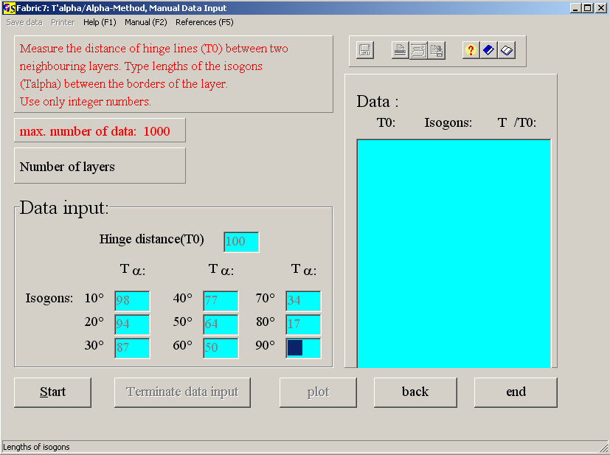 Fig. 2

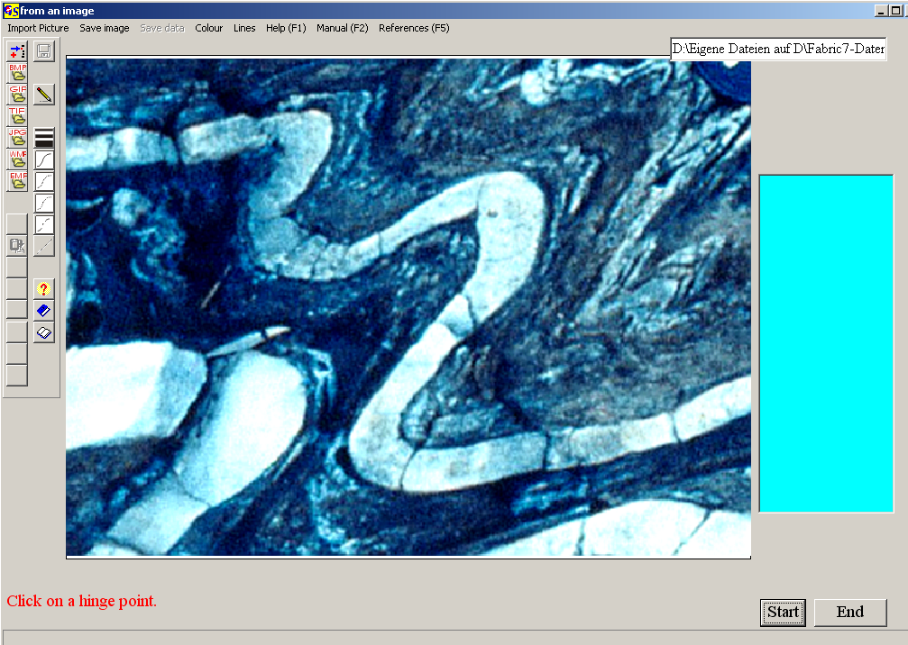 Fig. 3

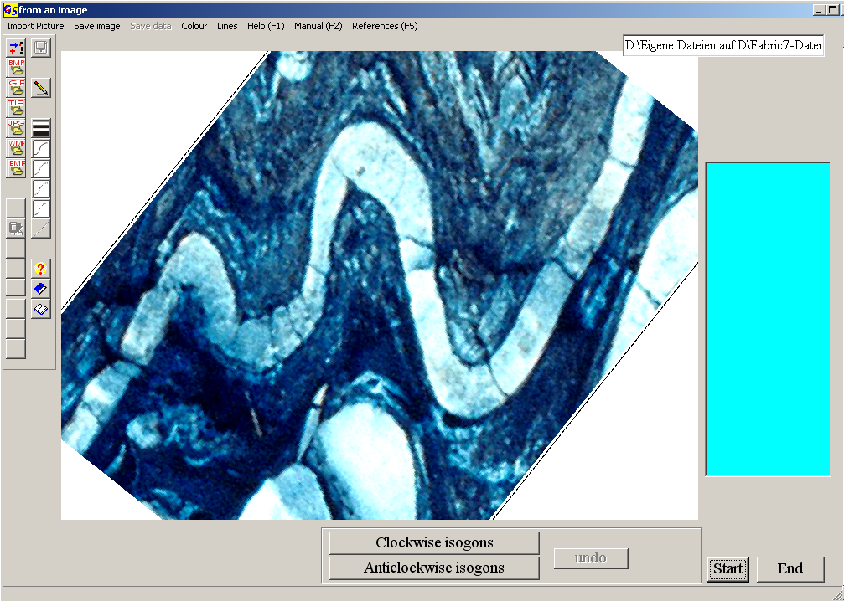
Fig. 4

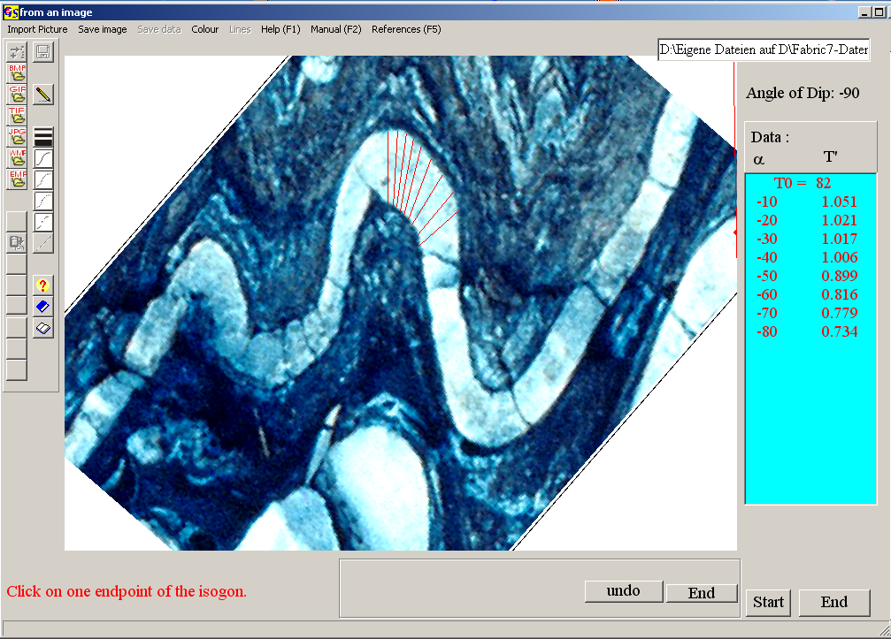
Fig. 5
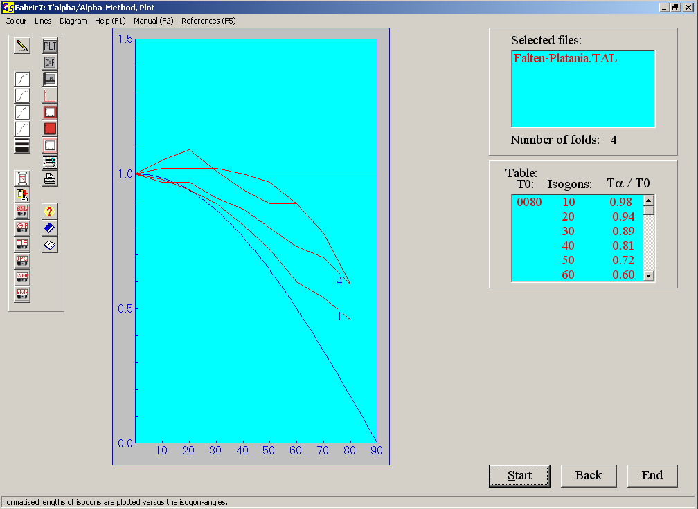
Fig. 6

The options of the menu "Diagram" are explained in program 3.

